Ana Katrina De Leon

1. A & D
2. C
3. C

Create table EMPLOYEE(

ID INTEGER PRIMARY KEY,

FIRST_NAME VARCHAR(20),

LAST_NAME VARCHAR(20),

MGRID INTEGER,

SALARY INTEGER);

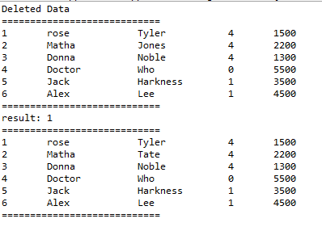 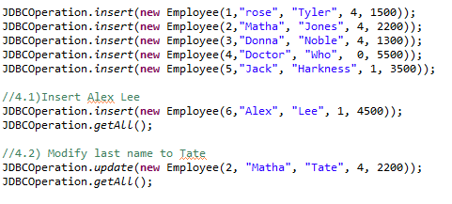

5) Used when the driver class name is not known. Just passing string and load class in the memory. It can be used to load the JDBC drivers directly.

6) Prepared Statement is a better version of statement, can be parameterized, and it is faster than the statement.

Statement is the one that parse the incoming sql query and compilation of the query, optimizing data acquision path and executing the optimized query.

7)

* resultSet.close();
* stmt.close();
* conn.close();